IMPORT CSV FILE
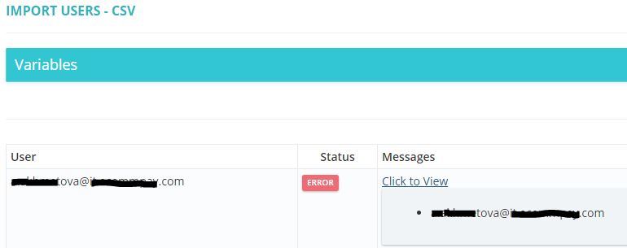

BULK EDIT
